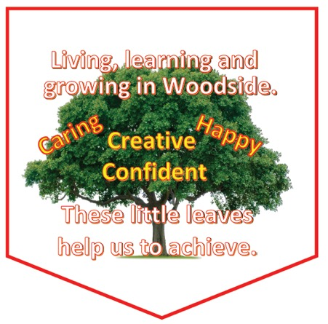

WOODSIDE PRIMARY SCHOOL

HANDBOOK 2023-2024

Contents

Introduction by the Head Teacher
About our school
School Ethos
Staff List
Attendance
Parental Involvement/Parent Council
The Curriculum
Assessment and Tracking
Reporting
Enrolment and Transitions
Support for Pupils
School Improvement
School Policies and Practical Info
General Data Protection Regulation as supplemented by the Data Protection Act 2018 (GDPR)

If you need this information in another language or format, please contact us to discuss how we can best meet your needs.

Phone: 0303 123 1023 Email: education@southlanarkshire.gov.uk.

Introduction by the Head Teacher

Welcome to Woodside Primary, our lovely, vibrant school. We love our fabulous building, enjoying all the facilities that it has to offer!

I hope that you will find our School Handbook interesting, informative and enjoyable to read!

Please do not hesitate to contact us should you wish any more information, or any points clarified. We’re happy to help!

In Woodside, we want the best for our pupils. Our aims, vision and values, were formed after consultation with members of our whole school community ~ children, staff, parents, grandparents, Parent Council, our friends and local business supporters. We are confident that having done this, our shared ethos is happy, vibrant, achieving, supportive, and the best it can be. We also aim to promote positive relationships and links within school, with our parents and the community. This is high on our priority list. I hope you will find us to be an open and approachable team. All Staff in the school have high expectations of our pupils – in learning, behaviour and in attitude. We work hard in achieving this and it is very important to us to work in partnership with our parents. Our curriculum is designed to provide our children with a broad and balanced general education, which builds on skills and incorporates support and challenge, when required.

We want to engage them fully and actively in their learning, so that the opportunities on offer enable our children to enjoy relevant and meaningful experiences, which allow them to be Successful Learners, Confident Individuals, Effective Contributors and Responsible Citizens – the four capacities of Curriculum for Excellence.

We very much appreciate your support and want to work with you to make this happen for our children, I look forward to meeting you soon!

Woodside Primary School is one of 124 primary schools throughout South Lanarkshire Council.
South Lanarkshire Council is the fifth largest authority in Scotland. It covers the following main areas: Clydesdale in the South, which features extensive rural areas, Cambuslang, Rutherglen, Blantyre and Uddingston to the North as well as the towns of East Kilbride and Hamilton.

The Council’s Plan, ‘Connect’ sets out the Council’s vision to improve the quality of life for all within South Lanarkshire.

For Education Resources, this means delivering services of the highest quality as well as striving to narrow the gap. It is about continually improving the services for everyone at the same time as giving priority to children, young people, families and communities in most need. The priorities for schools and services are set out in the Education Resources Plan, which confirms the commitment to provide better learning opportunities and outcomes for children and young people.

Elaine Renwick
Head Teacher

About Our School

Woodside Primary School

Johnstone Road
Hamilton
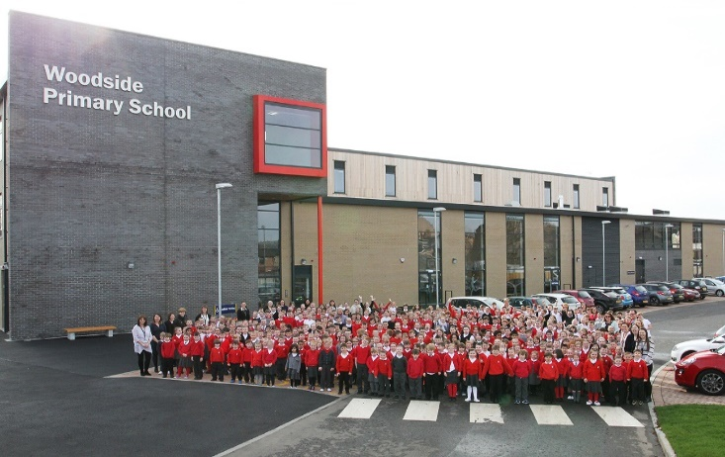
ML3 7JR

Phone: - Hamilton 01698 427811

email: - gw14woodsidepsoffice@glow.sch.uk

Website: - www.woodside-pri.s-lanark.sch.uk

Present Roll:- 500

Stages Covered P.1-7
Non-denominational

Parent Council e-mail: woodsideparentcouncil@hotmail.co.uk

Parental concerns or complaints

If a parent requires an appointment with the Head Teacher or Depute Head Teacher, please telephone our school office.

A member of the SLT will be available to help support you with any concerns or complaints. In the first instance, Mrs McKellar can support parents of Primary 1-3 pupils, and Miss Officer, parents of Primary 4-7 pupils.

All members of the School Leadership Team are open and approachable and will treat any concern with discretion.

Our Aims and Values

In Woodside Primary we live, learn and grow together in a caring and vibrant community, where learners are happy, creative, confident and encouraged to achieve great things.

At Woodside Primary School we aim to:
- Provide high quality learning experiences which equip our children with the skills for life, learning and work
- Support all our learners to attain and achieve
- Foster positive and meaningful relationships with families leading to a deep understanding of each individual child
- Promote and further build upon our positive, dynamic ethos
- Build strong partnerships within our local community
- Encourage leadership at all levels, empowering our learners and staff to strive for excellence

Our School Ethos

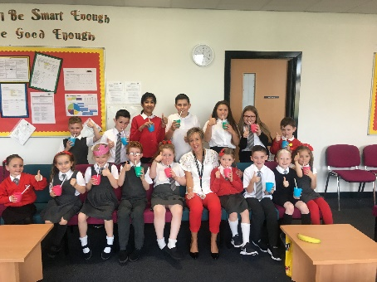
In Woodside, we work hard to create and maintain a very positive, friendly, vibrant school ethos. Although a large school, we are a family. Everyone has a part to play in this – Head Teacher and Deputes, Principal Teachers, the Staff and Support Staff Team, Janitor, Dining and Cleaning Staff, Pupils, Parents and Friends!

We hope you ‘feel’ this warm, happy and welcoming ethos the minute you step into our entrance hall!

Our children are full of enthusiasm! They are also interested, caring, respectful and proud of their school. Our ethos is very much, enhanced by colourful and inviting displays of children’s work and achievements. After consultation with our whole school community on our values and expectations of how we think a good school should be, together we came up with HAPPY, CARING, CONFIDENT and CREATIVE. Our children and staff within school talk frequently about these values and attempt to model them at all times.

We receive many compliments about our school from parents, visitors, outside agencies and our community. These include positive comments on the children’s behaviour in school, at assemblies, in class, and outside at events and visits. It is lovely to receive compliments, and these encourage us to maintain our reputation and keep trying to improve!

Our staff and support staff are a superb team. Good relationships, openness, approachability and trust are high on our shared agenda. We believe that it is important for our children to see these attributes being modelled and cascaded throughout the school.

Woodside enjoys warm partnerships with friends in our community.

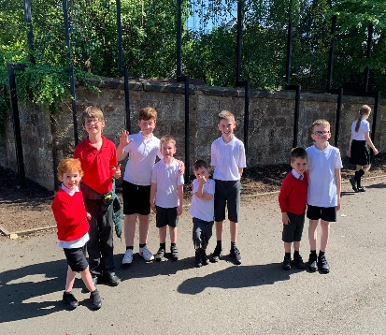
We are part of the Hamilton Learning Community and work very well with our Partner Primary Schools, Hamilton Grammar and many Early Years’ Establishments.

We love visiting our ‘neighbours’ and have them visiting us in school. We have strong links with our local Church too.

Our Woodside Team

Head Teacher Mrs Elaine Renwick
Depute Head Teacher Mrs Eileen McKellar
Depute Head Teacher Miss Charlotte Officer

P 1 Mrs Nicola Smith
P 1 Mrs Moya Ferguson
P 1/2 Mrs Victoria Yates
P 2 Miss Rudi Hendry
P 2 Mrs Gillian McCahon
P3 Mrs Stephanie Callaghan
P 3 Mrs Jade Dundas
P 3/4 Ms Ainsley More
P 4 Miss Danielle McAvoy
P 4 Mrs Carol Mackenzie
P 5/6 Ms Jane Lennox
P 5 Mrs Claire Meechan
P 5 Mrs Shiona Burke/Miss Rebecca Noble
P 6 Miss Lisa O’Hanlon
P 6 Miss Rachel Mearns
P 7 Miss Nicola Wilson
P 7 Mrs Angelia MacDonald
Class Contact Reduction Teachers Mrs Nicole Moffat and Mrs Rachel Allan

Equity Lead Miss Jennifer McLarnon (Principal Teacher)
Early Interventions Mrs Sarah Jane Aitcheson (Acting PT)
Mrs Kirsten Lawson (PT)

Youth,Family and Community Link Officer Evelyn McGonagle
Place 2 Be Councillor Claire Blaney

String Tutor Mr Graham Walker
Brass Tutor Mr Paul Devlin
Chaplaincy Team Rev. Joanne Hood/Rev. Ross Blackman
Support Staff Mrs Caroline Gibney,(Team Leader),Mrs Fiona Mitchell, Mrs Andrene Brownlie, Mrs Fiona Swan, Mrs Laura Rice, Mrs Linda Muncie, Miss Maureen Shanahan, Mrs Lynne Dalton and Mrs Victoria Abercrombie

Janitor Ms Nikki Gracie

Head of Education Carole McKenzie
Quality Link Officer Murray Stewart
Senior Manager of Pupil Support Martin McCabe
Support Services Co-ordinator Alison Smith

Attendance

Pupil Absence
It is important for us in Woodside to work with parents in encouraging all children to attend school. All absences from school are required by law to be recorded. Absences will normally fall under two categories – authorised or unauthorised. In cases where your child is unable to attend we would ask parents to: -
- Telephone the school office before 9.30am, if your child is unwell or has an appointment and is unable to attend school that day. This lets us know that your child is safe, and we can inform class teachers of any absence.
- Inform the school of the likely date of your child’s return or update school office regularly
- If the school has received no notification of a pupil’s absence, a member of the office staff will contact you in the first instance, then will go to your emergency contacts to check on the situation.
- Attendance rates are monitored each term. If your child’s attendance falls below 85% you will receive a letter to notify you of this.
- If you know your child has a medical appointment, please let us know in advance.
- Requests for your child to be absent from school to make an extended visit to relatives must be made in writing to the Head Teacher, detailing the reason, destination and duration of absence and arrangements for their continuing education. On these occasions the pupil will be marked as an unauthorised absence in the register.
- Parents may request that their children be permitted to be absent in order to celebrate recognised religious events. Advance notice should be provided to the school when children will be absent. Appropriate requests will be granted, and the pupil noted as an authorised absentee int the register. (see section 7)

We will always attempt to contact parents when a child becomes unwell during school. We do require that parents regularly update Parentsportal on changes of address, home and work telephone numbers, mobile numbers and emergency contacts.
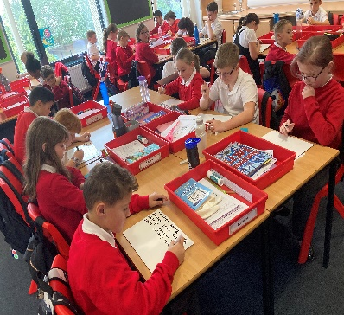
Family Holidays during Term Time
Every effort should be made to ensure that your child attends school during term time. Please contact the school as soon as possible if your child is unable to attend school. Family holidays should be avoided during term time as this both disrupts the child’s education and reduces learning time. If holidays are taken during times when the school is open, parents should inform the school in advance by letter.

If your child is taken on a family holiday during term time, then in line with the Scottish Government advice this will be classified as an unauthorised absence. However, in exceptional circumstances schools may register a family holiday during term time as an authorised absence when for example, parents are unable to obtain leave during the school holiday period.

Absence with no explanation from parents will mean that the absence will be recorded as unauthorised.

In our approach to raising attainment and achievement it is recognised that attendance at school is something that should be continuously encouraged. Parents/carers, children and the school all have a part to play in encouraging and stressing the importance of attendance at school.

The school holiday dates and InService dates are available from the website:- www.southlanarkshire.gov.uk

Information on emergencies

We make every effort to ensure the school remains open during term-time for pupils. However, on occasions circumstances may arise which can affect the school. Schools may be affected by, for example, severe weather, power failures or through any other circumstances that may impact on the school day. In such cases we shall do all we can to let you know as soon as possible. We shall keep in touch by the most appropriate method at the time, normally through Parentsportal, and via our social media channels.
In cases of severe weather in the morning, such as snow/heavy frost and if there is a reason that school cannot open at the normal time, we will adopt the protocol for a delayed start until 10.00am. If this is the case, a message will be posted via social media and on the council’s website.

The Council’s website www.southlanarkshire.gov.uk will be used to let you know if the school is closed or has a delayed start. Further information will be provided later in the day whether school will be open as normal the next day.

Things we need you to do:

- It is important for parents/carers to let the school know of any change to your mobile/home telephone number and change of address.

- If for any reason, you are unsure if the school is open visit the website www.southlanarkshire.gov.uk or email education@southlanarkshire.gov.uk

Your commitments

We ask that you:
- support and encourage your child’s learning
- respect and adhere to the schools policies and guidance

- accept your responsibility to respect staff who work in the school and for the school to be proactive in taking forward its commitment to care for and educate your child.

Parental Involvement/Parent Council

South Lanarkshire Council recognises the importance of parents as partners in the education of their child and has published a strategy entitled, ‘Making a difference – working together to support children’s learning’. This is available from the Council’s website: www.southlanarkshire.gov.uk/downloads/file/13457/parents as partners – strategy 2019

Parents, carers and family members are by far the most important influences on children’s lives. Children between the ages of 5 and 16 spend only 15% of their time in school! Research shows that when parents are involved in their child’s learning, children do better at school and throughout life. Parental involvement can take different forms but we hope you share the same aims and agree that by working together we can be partners in supporting children’s learning.
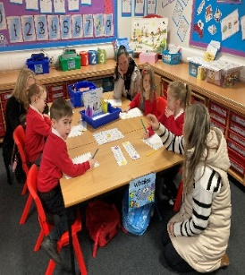
As Parents/Carers, we want you to be:
- welcomed and given an opportunity to be involved in school life
- fully informed about your child’s education and learning
- encouraged to make an active contribution to your child’s learning
- able to support learning at home
- encouraged to express your views and be involved in forums and
discussion on educational related issues

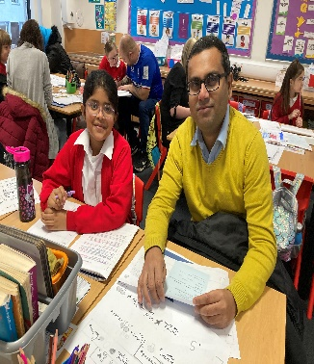
Home and School Links
We recognise that parents have a major role to play in the education of their children and we welcome as many links as possible between home and school. At the start of every session, you will receive a ‘Parental Engagement Calendar’. This outlines the many opportunities to be involved in your child’s learning over the school year.

If you would like to speak with a member of staff or the Leadership Team, contact the school to arrange an appointment prior to your visit. Please never hesitate to contact us to sort out small problems, as we would rather address concerns before they become serious.

We update our colourful and informative school website on a weekly basis. Here you will find out lots of information about the school and can see many photographs of our children. We also use ’Twitter’ to communicate with our parents too! Each class has its own ‘Google Classroom’ and ‘Class Newsletter’. This informs parents on what their child will be learning about and how to support them at home.

Our school newsletter goes on our website on the first Friday of every month and includes information about a wide range of school activities and events, as well as our curriculum and Improvement Plan updates.

We conduct regular surveys and welcome any comments or additional information from parents, to help us provide the best possible education for your child. If necessary, arrangements can be made to have an interpreter present at Parents’ Evenings or at other times as appropriate. Wheelchair access is available.

Helpers
In Woodside, we have a fantastic number of parents and friends who help us in classes, on outings, with clubs and in many other ways. Our volunteers make a huge difference to the activities we can offer and the way children learn. We also ask our parents to share their expertise with us through visits to talk about careers, assist with Science activities, and tell us about other world religions and customs. We welcome all volunteers and have a range of Secondary pupils, people seeking work experience with children, parents and grandparents.

Parents are encouraged to volunteer their services to the school. We require help in many aspects of our daily school life, such as helpers for outings and for many leisure activities. We do require all parents who help to be members of the Protection of Vulnerable Group scheme (PVG).

PVG forms are available from Charlotte Officer, Depute Head Teacher.

We endeavour to build up positive relationships with all our parents and encourage them to come into school to discuss any matter relating to their child's welfare.

Woodside Parent Council

Every parent with a child at school is automatically a member of our parent forum. The Parent Council is a formal group, with a constitution, and acts as the Parent Voice of the school.

Woodside has an enthusiastic and energetic Parent Council, this is a formal group with a constitution, and acts as the Parent Voice for the school. The only official role is that of Treasurer and this is currently held by Mr Jonathan Simpson. Mrs Julie Lamont and Mrs Claire Thom currently hold the roles of Parent Council Chair and Secretary.

To find out more on how to be a parent helper, or a member of the Parent Council please contact the school or visit our website. We have also produced a guide on the role of a Parent Council which can be found by visiting the parent’s area of our website. www.woodside-pr.s-lanark.sch.uk which was produced by parents for parents.

Parentzone Scotland is a unique website for parents and carers in Scotland, from early years to beyond school. The website provides up to date information about learning in Scotland, and practical advice and ideas to support children’s learning at home in literacy, numeracy, health & wellbeing and science. Information is also available on Parentzone Scotland, regarding additional support needs and how parents can get involved in their child’s school and education. www.parentzonescotland.gov.uk

Parentzone Scotland also has details about schools, including performance data for school leavers from S4-S6 and links to the national, local authority and school level data on the achievement of Curriculum for Excellence levels.

The Curriculum

Curriculum for Excellence is the name given to the curriculum in Scotland for all children and young people aged 3-18. It is a forward looking, coherent, more flexible and enriched curriculum that provides young people with opportunities to engage with the knowledge, skills and attributes that they will need to flourish in life, learning and work.

The curriculum places learners at the heart of education and at its centre are four fundamental capacities – successful learners, confident individuals, responsible citizens and effective contributors. It includes all of the experiences that are planned for children and young people to support the development of their skills, wherever they are being educated, for example in the family, and community, pre-school centre, nursery and school

In taking, this forward our school will work closely with South Lanarkshire Education Resources and other services to enrich the curriculum, to provide the best possible education for all children and young people. We wish you to feel confident that your child is encouraged and supported to develop their literacy, numeracy and other skills whilst they attend our school. The curricular areas are as follows:

- Expressive Arts
- Health and Wellbeing
- Languages and Literacy
- Mathematics and Numeracy
- Religious and Moral Education
- Science
- Social Studies
- Technologies

If you want to know more about Curriculum for Excellence, please visit Scotland's Curriculum for Excellence (scotlandscurriculum.scot)

Our learning and teaching activities are based on the outcomes and experiences in the guidelines that all schools have for Curriculum for Excellence.

Level Stage
Early The pre-school years and Primary 1 or later for some
First To the end of Primary 4, but earlier or later for some
Second To the end of Primary 7, but earlier or later for some

Language / Literacy
We aim to provide a balanced and structured programme through which children learn to:
- Listen carefully
- Talk clearly and fluently
- Read for pleasure and information
- Write appropriately in various ways
We use Active Literacy to teach phonics and spelling. This phonics-based approach enables children to develop strategies to read and spell unfamiliar words. Reading is crucial in enabling children to succeed throughout the curriculum.
At Woodside, children initially learn to read using decodable texts, which closely match the new sounds and high frequency words they are learning. This supports all children to establish strong early reading skills. Once core reading skills are established, the children use a wide range of texts including novels, non-fiction texts, poetry and media.
At Woodside we aim to not only teach the children how to read but also to foster a love of reading. Our Reading Spine ensures that children are also read to every day using high quality children's literature.

We use the Talk for Writing framework to ensure children understand the structure and elements of written language and have opportunities to write independently for a variety of purposes. This approach also ensures oral language skills are developed and expanded to improve the quality of written work.

At all stages, (P1-P7) as part of the Languages 1+2 programme, children study French as their Modern Language, and at 2nd Level (P5-P7) pupils will participate in a series of lesson in Mandarin and Chinese culture.

Mathematics / Numeracy
Our maths pathways ensure our curriculum is both progressive and provides opportunities for children to build upon their numeracy skills in line with Curriculum for Excellence.
Mathematics plays an important role in all our lives and is an activity involving processes such as discovering, discussing, ordering, classifying, generalising, drawing and measuring. We encourage children to explore numeracy strategies and verbalise their thinking. ICT is used to support learning and all children have their own ‘Sumdog’ account that they can access at home.

Health and wellbeing
The purpose of the Health and Wellbeing curriculum is to develop the knowledge, understanding skills, capabilities and attributes necessary for mental, emotional, social and physical wellbeing. It is the responsibility of every teacher to contribute to learning and development in this area.

Physical Education is included in this area of the curriculum. We teach all children the value of participation in a range of sporting and physical activities. Each pupil is entitled to two hours of Physical Education per week. Most classes have one PE slot indoor and one PE slot outdoors.
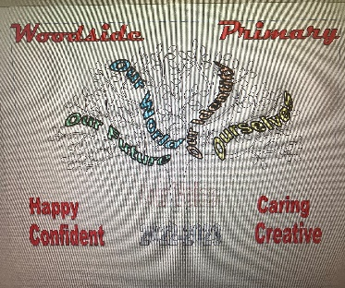
Other areas of Health and Wellbeing include
- planning for choices and change (career education)
- food and health
- substance misuse
- relationships, sexual health and parenthood

Over the past couple of years we have focussed on evaluating our curriculum and are continuing to develop a new progressive curriculum which we believe best suits our children in Woodside. Each term learning will be linked to a theme. Our themes will be Ourselves, Our Identity, Our World and Our Future. Across the school, every child’s topic work will relate to this theme. Our literacy, numeracy and aspects of health and wellbeing will remain as separate core learning.
Our termly themes, will stimulate children’s awareness and understanding of their environment and their place in it. This means that teachers ensure that contexts for children’s learning are relevant, challenging and enjoyable. Over the year, children have the opportunity to learn about their local culture, historical events and Scotland’s place in the world.
We also make full use of our local environment and the various agencies within it, taking children out into the community as much as possible. A range of ICT experiences, allow our pupils to develop the appropriate skills and knowledge for the future. ICT permeates our curriculum.

We use Art, Music, Drama and Dance, to stimulate the imagination and develop a child’s emotional and aesthetic responses. We aim to give children the opportunity to enjoy and appreciate the arts and provide experiences through which they may express themselves in a variety of ways. This will enable them to shape their impressions through feelings, emotions, intellect and skills.

Spiritual, Social, Moral and Cultural Values (Religious Observance)
Religious Education Guiding Principles in Woodside

Religious Education;
- makes a distinctive contribution to the curriculum in Woodside in helping pupils towards a consistent set of beliefs, values, attitudes and practices.
- such experience will be interpreted within a Christian framework, which recognises the diversity within our community and promotes these.
- encourages pupils to become aware of a wide range of religious interpretations of personal experience and of their importance to believers.
- fosters attitudes of open enquiry and awareness of prejudice. Religious education in Woodside should help pupils to appreciate that religion offers a distinctive interpretation of life. It also encourages them to think honestly for themselves about religious beliefs and practices, and the implications of moral issues within world religions.

Religious Observance;
- contributes greatly to the Woodside ethos and provides opportunities for the school to come together as a community;
- is a valid educational experience potentially involving the whole school and the wider local community;

Within our school, there exists a broad spectrum of religious and non-religious belief. In religious observance, we respect the different beliefs of pupils, teachers and parents.

Spiritual, social, moral and cultural values
Rights of Parents/Carers
Scottish Government Ministers consider that religious observance complements religious education and is an important contribution to pupils’ development. It should also have a role in promoting the ethos of a school by bringing all pupils together and creating a sense of community.

Parents may request that their children be permitted to be absent in order to celebrate recognised religious events. Advance notice should be provided to the school when children will be absent. Appropriate request will be granted, and the pupil noted as an authorised absentee in the register.
There is a statutory provision for parents to withdraw children from participation in religious observance. The right of parents’ wishes will be respected. Where a child is withdrawn from religious observance, schools will make suitable arrangements for the child to participate in a worthwhile alternative activity. If you wish to withdraw your child, please put it in writing to our Depute Head Teacher.

Equalities
Integral to this guidance is the principle of mutual respect. The diversity of belief and tradition provides an ideal context in which pupils can learn about and to learn from what is important in the lives of themselves and others. South Lanarkshire’s guidance recognises and welcomes diversity and promotes respectful understanding.

Assessment and Tracking Progress

Woodside’s arrangements and approaches for tracking and assessing pupils’ progress and planning their future learning, involves us gathering, reflecting upon and evaluating both summative and formative evidence of our children’s learning. This enables our staff to check on learner’s progress, and establish and support next steps. Pupils are regularly encouraged to use Assessment for Learning, to self and peer assess their work, as well as set future targets. Our Senior Leadership Team and all staff monitor and regularly track the progress children are making.

Individual assessments are also undertaken to help diagnose gaps in learning or to support children with their personal next steps. These can include reading and spelling age assessments and MALT assessments for numeracy.
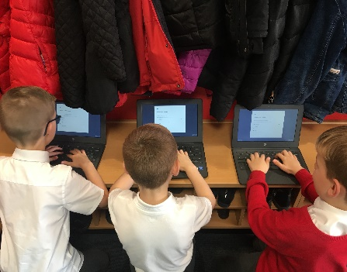
Our Primary 1,4 and 7 children all complete the Scottish National Standardised Assessments on aspects of reading, writing and numeracy. The online assessments are specifically designed. If a child is experiencing difficulty, the questions will get easier, and if a child is doing well, the questions will become more challenging. There is no pass or fail. The assessments are as short as possible and are age and stage appropriate. There is no time limit and the children will not need to complete all the assessments at once. These new, nationally developed assessments provide teachers with further information on how each child is progressing and help in planning next steps in learning.
Children’s progress in literacy and numeracy, are updated and tracked termly. Our Senior Leadership Team discuss, monitor and evaluate this information with teaching staff.

We want to share with you on how your child’s learning is progressing. We do this through, parental phone calls, parental meetings, report cards, ‘Class newsletters’ and Open Events.

Reporting

Woodside Primary School recognises that good teamwork between parents, children and school is the key to a successful education for your child.
Reporting will be ongoing and comprise of a range of activities that can include children presenting their learning, through newsletters, open mornings, learning journals and ongoing oral discussions.
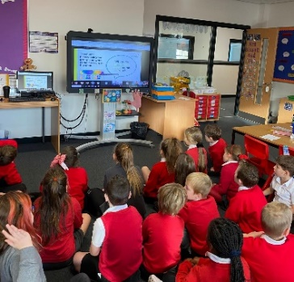
We will provide parents with reports so that you can see what your child is doing and how they are developing. In addition, there will be parents meetings, which offer you the opportunity to discuss how your child is progressing. You can book your appointment on Parentsportal.

Our ‘learner reports’ will help you get to know more about the curriculum which each child follows and will describe strengths, achievements, and areas for development so you know what encouragement and support you can give.

We welcome any comments or additional information from parents to help us provide the best possible education for your child.

Enrolment and Transition

Enrolment – how to register your child for school.

To register your child for school you should complete our online registration form. This can be done using the South Lanarkshire website www.southlanarkshire.gov.uk/info/200186/primaryschoolinformation/392/enrollingyourchildforschool
If you have any difficulty in identifying your catchment school, please email edsuppserv.helpline@southlanarkshire.gov.uk
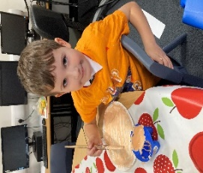
The online registration form will ask you to provide each child’s full birth certificate and two pieces of recent official documentation both containing your permanent home address for example a utility bill, council tax statement, housing rent card, child benefit documentation. Proof of where the child lives may also be needed.
If your child is due to start school in August 2024, you can enrol online from Monday, 8th January 2024. Your catchment school will contact you between Monday 15th and Friday 19th January 2024 to confirm your enrolment.
If your child attends nursery of your catchment school don’t assume that they will be automatically transferred. You must register them as normal at the school that is in the catchment area for your home address.
If parents want their child to go to another school, they must enrol in the first instance with their catchment school and inform them that they wish to make a placing request. An online placing request form is available from the SLC website www.southlanarkshire.gov.uk, or by contacting edsuppserv.helpline@southlanarkshire.gov.uk or phone 0303 123 1023

Change of School/Placing Request

Normally children attend the school in their catchment area. However, there are times when parents may wish their children to go to other schools. If you wish your child to go to another school, then you may make what is known as a ‘placing request’. If you live in South Lanarkshire and decide to submit a placing request, we are unable to reserve a place in your catchment school until the Council have made a decision on the ‘placing request’. Please note if your placing request application is unsuccessful and all places at your catchment school are filled you will be offered a place at the next nearest appropriate South Lanarkshire School.

Please not that if an application for a ‘placing request’ is successful, no school transport is provided.

If you move outwith your catchment primary school, a ‘request to remain’ form must be completed. This also may affect your rights to transfer to the associated Secondary School. Please note the Secondary school is determined by the pupil’s permanent home address and chosen denomination. If you require further information, please contact Education Support Services on edsuppserv.helpline@southlanarkshire.gov.uk or 0303 1231023.

Transition from Primary to Secondary
Pupils normally transfer from primary to secondary school between the ages of 11½ and 12½, so that they will have the opportunity to complete at least 4 years of secondary education. Primary schools will make arrangements to transfer children to the associated secondary school as determined by their home address. Information is sent out to parents of P7 children of the transfer arrangements for their child to attend secondary school.

At this time, we will provide you with information on events designed to support P7 children before they move on to secondary school.

Woodside Primary is an associated primary of Hamilton Grammar, Auchincampbell Road, Hamilton. Phone 01698 285777.

Support for Pupils

Getting it right for every child.
Getting it right for every child (GIRFEC) supports families by making sure children and young people can receive the right help, at the right time, from the right people. The aim is to help them to grow up feeling loved, safe and respected so that they can realise their full potential.
Most children and young people get all the help and support they need from their parent(s), wider family and community but sometimes, perhaps unexpectedly, they may need a bit of extra help. GIRFEC is a way for families to work in partnership with people who can support them, such as teachers.
If you have any concerns about your child’s wellbeing, you can speak to the named person who will work with you to provide support and decide how to move forward. Your school will let you know who this is. It is likely to be the Head Teacher in a Primary School and the Principal Teacher (pupil support ) in Secondary.

More information can be found on www.scotland.gov.uk/gettingitright

Support for All (Additional Support Needs)
The Depute Head Teacher, Mrs McKellar is responsible for co-ordinating Support for Learning in our school. In Woodside, we operate a process of staged intervention in the identification, assessment and support for the learning needs of our children.

Stage 1 and 2: Intervention within class/school
Personnel involved in this stage would include class teachers, parents, school support assistants, Depute Head Teachers. Additional resources appropriate to individual needs would be investigated and included in programmes where necessary.

Stage 3: Intervention from education services outwith school.
At this stage, the support and advice of a range of specialist professionals may include Specialist Support Services Teacher, Educational Psychologist, Behaviour Support and E.A.L. teachers.
If appropriate, an Additional Support Plan would be written at this stage, indicating both long and short-term targets in the area(s) of difficulty.

Stage 4: Multi - Agency Intervention
The Depute Head Teacher would co-ordinate the involvement, where appropriate, of one or more of the agencies.

South Lanarkshire Education Resources have published a series of leaflets available, which cover information for parents and carers about the Additional Support for Learning Acts.

Enquire – The Scottish Advice Service for Additional Support For Learning
Enquire is funded by the Scottish Government to provide information on the framework for supporting children who require additional support for learning and to encourage positive partnerships between families, schools and local authorities to ensure children get the right support.
Enquire offers independent, confidential advice and information on additional support for learning through:

Address Enquire Phone Helpline: 0345 123 2303
Children in Scotland
Rosebery House
9 Haymarket Terrace
Edinburgh EH12 5EZ

E-mail Enquiry Service info@enquire.org.uk

Advice and information is also available at www.enguire.org.uk

Enquire provides a range of clear and easy to read guides and fact sheets including ‘The parents’ guide to additional support for learning.

Attachment Strategies for Education Resources

Attachment – what we do to support children and young people
South Lanarkshire Council Education Resources is committed to improving outcomes for children and young people by creating emotionally supportive learning experiences in our nurseries and schools.

The Education Resources Attachment Strategy supports the action in the ‘Getting it Right for Every Child in South Lanarkshire’s Children Services Plan 2021-23’, following the launch of the Attachment Strategy in 2020, to provide staff training in Attachment and Trauma based practice.

What does it set out to do?
The aim of the strategy is to promote better experiences of attachment for South Lanarkshire’s children and young people and to ensure that all education practitioners understand the importance of attachment theory and its application and how positive relationships can make a difference to outcomes.

How can I find out more?
South Lanarkshire Council Education Resources have published a series of leaflets and posters for establishments and for parents/carers which aim to share information on attachment theory and on how this can inform the ways in which we support children and young people. These are available from schools and on the SLC Staff Learning Centre Sway accessible by teachers and staff.

School Improvement

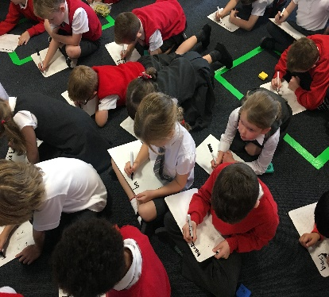
Our School Recovery Plan outlines the priorities in maintaining our high standards and sets out priorities for future developments. Plans are discussed with our Parent Council each session. These are available for parents from the school office or our website.

A Standards and Quality Report is compiled towards the end of each session. This report outlines the main achievements of the school over the last 12 months and a copy of this can also be found on the school website.
Key Successes and Achievements Session 2023/24
Key Successes:-

- A clear and consistent T4W framework has now developed.
- Shared and consistent approach to feedback in writing.
- Primary 4 and Primary 7 cohorts writing attainment has increased.
- All Primary 1 staff successfully undertook in Maths Recovery CLPL.
- P1 and P4 attainment increased.
- Outdoor learning environment created.
- All staff undertaken CLPL on outdoor maths.
- All children experienced at least 3 outdoor maths sessions.
- Learner conversations take place, following GWA results and if appropriate, supports implemented.
- Structured opportunities for collaboration, of the joint working of YFCL and Place2Be has begun.
- Every child is part of a Pupil Voice group.
- Whole school overview is progressive and bundled into 5 key themes: - Ourselves, Our Identity, Our World, Our Future and Our Voice.
- RME curricular overview, which is fully inclusive of our current school demographic.
- New planned theme days.
- Parental partnerships to support our curriculum design have been established.
- Combined literacy gap at P1, P4 and P7 for SIMD1and2+FME has reduced by 3%.
- Combined reading gap at P1, P4 and P7 for SIMD1and2+FME has reduced by 1%.
- Combined numeracy gap at P1, P4 and P7 for SIMD1and2+FME has reduced by 3%
- 50% of targeted group attendance rates increased.
- 29% of targeted families received supports/interventions from our YFCL Officer

Improvement Plan priorities session 2023/2024

Priority 1 - Continue to review our curriculum
- Health and Wellbeing curriuculum is progressive, relevant and coherant.
- SLC Technologies planners enhance our schools curriculum and are resourced.
- Indoor and outdoor PE curriculum ensures coverage of all experiences and outcomes.
- All children can name and explain the 4 capacities.

Priority 2 - Increase our attainment in Writing.
- Progressive nonfiction Talk4Writing approach implemented consistently across the school.
- Primary 1 pupil’s will have completed the SLC FLIPP programme, increasing early phonological awareness skills.
- Writing attainment increases.

Priority 3 - Improve nurture and behaviour approaches across the school.
- All classroom learning environments will be built upon positive and nurturing relationships.
- Shared behaviour management strategies and classroom organisation.
- De-escalation stations in place in each classroom/on each floor resourced with range of calming items.
Relationship and Anti Bullying Policies created.

Priority 4 - Excellence and Equity
- Continue to reduce our numeracy gap.
- Continue to reduce our writing gap.
- Increase our attendance rates for targeted group.
- Provide more supports from Place2Be.
- Provide more parental supports from our YFCL Officer
- Review our ‘Cost of the School Day’ Policy and use of our Participatory Budget.

We use our Scottish Attainment funding for the following areas to support pupil equity:-
- Staffing:- which includes an Equity Lead and Support Staff
- Place2Be Councillor
- Youth, Family, Community and Learning Officer
- Literacy and Numeracy resources and assessments.
- Payment of afterschool clubs, Primary 7 residential and class trips.

More information about our Improvement Plan can be found on the school website.

School Policies and Practical Information

School Meals
Healthy eating is something that the school supports, and a range of meals are available at lunchtime that meet the Nutritional Requirements for Food and Drink in Schools (Scotland) Regulations 2020.
School lunches and milk can be paid through your Parentpay account or Paypoint facilities in local shops.
All primary aged pupils are also offered a free breakfast within their school. The selection available includes cereal, toast, fruit and milk.
For their lunch each day pupils have the option to choose from two hot meal options,plus a snack option. These are all served with vegetables or side salad. All meals also come with fresh chilled drinking water, salad, seasonal fruit and depending on the day - soup or a dessert.
Milk will be available for those pupils entitled to free school meals through the free school meal eligibility scheme at morning break or lunchtime.

Pupils in Primary 1 – 5 receive a government funded school lunch
P6 and P7 lunches cost £2.05

Milk can be purchased at 29p for those children not in receipt of free school meals.
School lunches and milk are paid through your Parentpay account or Paypoint facilities in local shops.

NB School Meal prices are reviewed annually and may be subject to change
Adapted diets If your child within Nursery, Primary or Secondary requires an adapted diet for medical reasons please complete the form which can be found on our website. In addition, if you have a cultural diet request for your child, please complete the form which can be found on our website. woodside-pri.s-lanark.sch.uk
We recognise how important it is for children to have access to water during the school day. In Woodside, we have a water cooler on each floor. We strongly encourage children to bring a water bottle, which can be refilled as required during the day.

Free School Meals
Children of parents who receive the following benefits are entitled to a free lunch time meal for their child:-
- Income Support, Universal Credit (where your take home pay is less than £726.00 per month), Job Seekers Allowance (income based), Employment and Support Allowance (income related), Working Tax Credit and Child Tax Credit (where your gross annual income does not exceed £8,717 as assessed by the HM Revenues and Customs), Child Tax Credit only (where your gross annual income does not exceed £18,725 as assessed by the HM Revenues and Customs) or receive support under Part V1 of the Immigration and Asylum Act 1999.

If you are in receipt of housing benefit and /or council tax reduction from us there is no need for you to apply on line, we will use the information we hold to automatically award free school meals (P4-S6) and /or school clothing grants (P1-S6) to eligible families
We would encourage parents of children who are in receipt of any of the above benefits to take up this opportunity of having a meal provided for their child when they are at school. Arrangement are in place so that children who receive free meals are not singled out and we encourage all children to remain in school at lunchtime. If your child is a home lunch they must be collected from the school office by an adult.

South Lanarkshire Council also offers a free Breakfast service. In Woodside we currently operate a ‘Toast to Go’ service which operates from 8.30am -9.00am each day.

School Uniform
We ask all parents and carers to support the school by encouraging your child(ren) to adhere to the agreed dress code and the wearing of our school uniform. The wearing of a school uniform helps promote the identity of our school in the local community and helps create an ethos of sharing and pride in the school.

In addition, it helps to increase the protection of all pupils. Wearing a uniform helps staff and pupils to distinguish between who belongs to the school and those who may be visitors. This enables staff to approach and identify visitors more readily and helps in trying to offer a safer environment for pupils and teachers alike.

Equality of opportunity is an important aspect in the life of the school and any proposals on the wearing of a uniform will be the subject of consultation with parents, pupils and staff.

There are forms of dress, which are unacceptable in all schools such as:
- wearing of football colours
- clothing with slogans which may cause offence (anti-religious, symbolism or political slogans)
- clothing which advertises alcohol, tobacco or drugs
- clothing which can be deemed unsuitable on Health and Safety grounds, such as, shell suits, combat style clothing, dangling earrings, loose fitting clothes, particularly in practical classes
- articles of clothing could inflict damage on other pupils or be used by others to do so
- footwear which may damage flooring

Woodside Primary - Uniform
Our uniform is black/grey, trousers/skirt.
Red sweatshirt/sweater.
White shirt and school tie
Red/white polo shirt.

ALLERGIES
A significant number of children and young people in our schools will have allergies and it is important that parents keep the school fully informed on these matters.

Allergies can present in a variety of ways and can occur at any point in a person’s life. Symptoms range from mild to severe. Children and young people known to have an allergy with moderate to severe symptoms will likely have a Health Care Plan drawn up by the NHS. This will detail symptoms and appropriate interventions.

It is vital that parents share this information with the school and continue to provide any updated information.

Where symptoms are mild and a Health Care Plan is not in place, parents should still continue to liaise regularly with the school on any new triggers, medications and actions required.

In all cases, our employees need to know your child’s symptoms, treatments and any actions required to help prevent exposure to the allergen and minimise the risk of allergic reactions.

Employees in schools will receive training on allergies and will liaise with parents and NHS on any additional specialist training required.

In supporting children and young people with allergies, school employees will operate in accordance with South Lanarkshire Council’s Safe Systems of Work/risk assessment and national guidance on the administration of medicine.

Support for Parent/Carers

Clothing Grant
In certain circumstances, the Council provides support to parents/carers for the purchase of school wear. We would encourage families, if they are eligible, to apply for this.

Application can be made online at www.southlanarkhsire.gov.uk If you are required to submit evidence of your Tax Credit income it is important that a copy of this evidence is attached to your online application. Should you require further information or you are unable to submit an application online, then please contact the helpline number on 0303 123 1011 (option 5)

School Holidays

Type of Holiday | Holiday Dates
February Break | Monday, 12th & Tuesday 13th February
In-Service Day – all schools | Wednesday, 14th February
Spring Break/Easter | School closes at 2.30pm on Thursday, 28th March  School re-opens on Monday, 15th April
In-Service Day – all schools | Thursday, 2nd May
May Day | Monday, 6th May
Local Holiday | Friday 24th & Monday 27th May
Summer Break | School closes at 1.00pm on Wednesday, 26 June

Good Friday falls on Friday, 29th March 2024
Lanark schools will close on 6th and 7th June 2024
Pupils attend school for 190 days and teachers attend for 195 days

School holiday dates and in-service dates can be viewed on the website
www.southlanarkshire.gov.uk

School Transport
South Lanarkshire Council has a policy of providing school transport to primary pupils who live more than one mile by the recognised shortest walking route from their catchment school. This policy is more generous than the law requires. This means that the provision of transport could be reviewed at any time. Parents who consider they are eligible should complete a form online at www.southlanarkshire.gov.uk or contact 03031231023

These forms should be completed and returned before the end of March for those pupils beginning school in August to enable the appropriate arrangements to be made. Applications may be submitted at any time throughout the year and will be considered by Education Resources.

A privilege transport scheme is operated for mainstream school contracts where a pupil is not entitled to free school transport. Privilege transport will only be granted providing there is spare capacity on our existing school contract and will be from and to designated pick-up and drop-off points. Privilege transport will not be provided where a service bus is used on the school run. Any spare capacity will be allocated using agreed priorities.

More information on school transport is available www.southlanarkshire.gov.uk/info/200188/secondary_school_information/545/school_transport or phone 0303 123 1023.

Pick-Up Points
Where school transport is provided it may be necessary for pupils to walk a certain distance to the vehicle pick-up point. Walking distance in total, including the distance from home to the pick-up point and from the drop-off point to the school in any one direction, will not exceed the authority's distance limit for school transport. It should be noted that it is the parent's responsibility to ensure that the child behaves in a safe and acceptable manner while travelling in and alighting from the vehicle. Misbehaviour can result in your child losing the right to school transport.

Parents are asked to note that South Lanarkshire Council does not provide transport for those pupils who attend school via a placing request.

Insurance for schools – pupils’ personal effects

South Lanarkshire Council is concerned at the level of claims being received for loss or damage to pupils’ clothing or personal effects. Parents are asked to note the Council’s position in terms of insurance for pupils’ personal effects:

- Theft/loss of personal effects

The Council is not liable for the loss or theft of pupils’ clothing or personal effects for example mobile phones, tablets etc. Any items are therefore brought into the school at pupil/parents’ own risk.

Parents can assist by ensuring that valuable items and unnecessarily expensive items of clothing are not brought to school.

School staff have been advised not to accept custody of any such items.

The same principle applies to musical instruments and other equipment used for activities within the school, which belong to the pupil, but are brought into the school. Parents should be aware that if such equipment is left in school, it is done at the pupil/parents’ own risk.

In the case of valuable items such as musical instruments, parents should ensure that these items are covered by their own household insurance.

- Damage to clothing

The Council is only liable for damage caused to pupils’ clothing where the damage has resulted from the negligence of the Council or one of its employees. Claims arising otherwise will not be accepted by the Council’s insurers.

Promoting Positive Behaviour

It is the responsibility of the Headteacher and all staff within the school to ensure that parent council members, parents and pupils are involved in the creation of a positive school ethos that encourages good behaviour. Equally the school whilst trying to promote positive behaviour, must support young people should incidents or bullying occur. Parents have a significant role to play in working with the school, so that teachers, parents and pupils know what is expected of them in trying to change the behaviour and attitudes that contribute to bullying behaviour.

Our approach is to create an environment where better behaviour will encourage better learning. The school along with the support of parents, can work together to create a learning environment which young people can enjoy and feel safe.
Incidents of bullying should be reported to the school immediately so that each alleged incident can be looked at. Together we can work towards creating a safer school for children and staff.

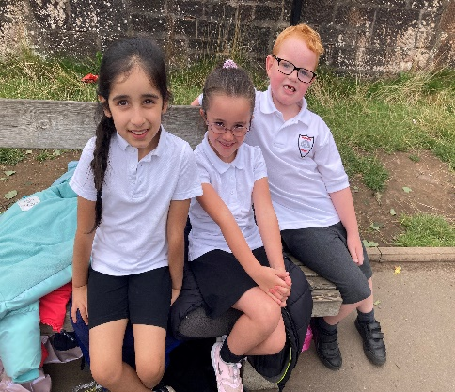
A guideline (Promoting Positive Relationships and Behaviour) has been produced to support all teaching and support staff and inform them of their roles and responsibilities in respect of dealing with the small number of children and young people who display challenging behaviour. Early identification is crucial so that intervention can be provided to support children and young people to help them address their issues and concerns. Staff training is provided to help develop the skills needed to respond to and manage challenging behaviour. A wide range of appropriate staff training opportunities has been developed for this purpose. In Woodside, we have created our own Relationships Policy. This was created in consultation with all our pupils, staff and parents and can be found on our school website.

We have a very positive house system in which all our children and staff have been ‘sorted’ into. Our 4 houses are:- Ash (Blue), Oak (Green), Chestnut (Yellow), and Maple (Red).
Children and staff earn points for a variety of reasons, including being polite, displaying good manners, demonstrating a caring attitude towards peers, being helpful, putting in extra effort with their learning and many more. The winning house at the end of each term will be rewarded with a treat and the overall winning house for the year will receive a special treat and have their name engraved on the house shield. Our Primary 7s have the chance to become House Captains and Vice Captains. They will take on the role of leading their house, being positive role models for their peers and encouraging them to work together to earn points. This system aims to encourage a real sense of pride and achievement for all children and fosters community spirit. It also allows both pupils and teachers time to form positive relationships with others throughout the school.
In Woodside Primary, we aim to establish a relationship between pupils and staff similar to those existing between parent and child.

Woodside ‘Buddy’Club – ‘Big Buddies, Wee Buddies’
Our P6 and P7 pupils participate annually in a training programme to become a ‘big buddy’. Children displaying the necessary skills are ‘buddied up’ with our younger pupils (P1&P2) and can meet up with them at regular times throughout the week. ‘Buddies’ are paired up for social reasons, e.g. – to help P1 pupils (or new pupils) settle into school life, and also to raise achievement in curricular areas e.g. – ‘Big Buddies’ listen to their ‘Wee Buddies’ reading.
Child Protection

All staff in educational establishments in South Lanarkshire Council receive an annual Child protection update and are required to follow the advice and guidance contained within relevant Education Operating Procedures. They must also complete a mandatory Learn on Line Course (Child Protection in Education)

South Lanarkshire’s children’s services partnership works together to support children young people and their families so that children grow up in communities where they are safe, healthy, active, achieving, respected, responsible and included, and have the opportunity to achieve their full potential. They are committed to continuously improve our services to ensure children, young people and their families get the right support at the right time. Sometimes children and young people need additional help to make sure that they are “cared for and protected from abuse and harm in a safe environment in which their rights are respected” (CPC South Lanarkshire Child Protection shared vision). The Child Protection Committee has the overarching responsibility to ensure that agencies individually and collectively work to protect children and young people as effectively as possible.
All staff have a responsibility to report any suspicions that a child has been abused or is at risk of harm, abuse, or neglect. Robust procedures and guidance are in place to support education staff to: -
- be alert to signs that a child may be experiencing risks to their wellbeing,
- report concerns to the head of establishment or the child protection coordinator without delay.
- be actively engaged in support and protection and development of wellbeing

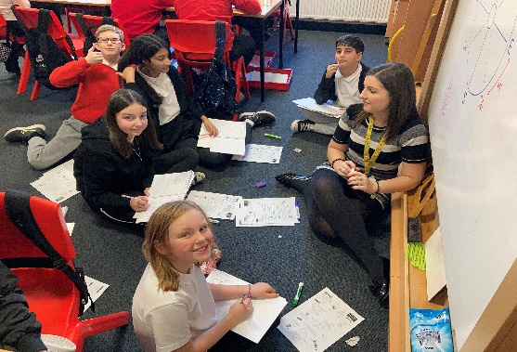
If you would like more information, or have a concern of a child protection nature, please contact Mrs Renwick, Child Protection Officer, at the school.

The Child Protection Committees website has a range of useful information for parents/carers to help them keep their children safe. www.childprotectionsouthlanarkshire.org.uk

General Data Protection Regulation as supplemented by the Data Protection Act 2018 (GDPR)
Information on pupils, parents and guardians is held by the school to enable the teaching, registration and assessment of pupils as well as associated administrative duties. The information is stored and used as per the requirements of the GDPR, with South Lanarkshire Council defined as the data controller. The Council have established a data protection policy that applies to all of its school.
Education Resources has also prepared a privacy notice (below) which sets out how we will deal with personal information as part of our statutory function as an education authority. For more information please contact the school.

Privacy Notice
Introduction
In line with the General Data Protection Regulation (GDPR) we have produced this privacy notice to inform you how we deal with personal information as part of our statutory function as an education authority.
The Council has a legal obligation to deliver effective education services to children, young people and adult learners in South Lanarkshire. In order to do this we need to collect personal information about children, young people and their families so that we can help them to learn and keep them safe.
Using your personal information
The Council is a “controller” of the personal information you provide when enrolling for a nursery or school, applying for an education service or participating in groups or activities provided by Education Resources.
Information we collect from you about you and your child at enrolment
When you enrol for a nursery or school, we ask for the following information:
- parent/carer contact details (name, address, phone, email);
- the child’s name, date of birth, gender and address;
- information about medical conditions, additional support needs, religion and ethnicity;
- any information you may wish to provide about family circumstances.
Information we collect at other times
We will also collect information at other times such as when you apply for a benefit, request a services or other support. We will provide an additional privacy notice at these times.
- When you apply for an education service or benefit, such as school transport, free school meals, clothing grant, placing request or EMA, we will also ask for personal information as set out above. We will also ask for information about your income for education benefits applications.
- If you make a request for additional support such as an educational psychologist or other support for learning we will ask for more detailed information to allow us to provide the most appropriate support for your family. This may include information about family circumstances or medical conditions.
- If there are concerns about your child’s wellbeing and/or your child has needs that may require additional support, we will wish to work with you to collect and consider information to enable us to help you to get the right support at the right time in line with getting it right for every child approach.
- If you wish to participate in activities or support for young people through our youth centres, or through adult learning programmes within the community, we will also ask for your personal information to support your application. This may include information about family circumstances or medical conditions.

We require this information to ensure that children and young people are educated appropriately, supported, and that we take account of their health and wellbeing. We will also ask you to update this information annually and to tell us when there are changes to your details.
Information that we collect from other sources
As an education authority and as part of our statutory function in accordance with our legal obligations, we receive information from other sources such as the SQA, the NHS or Social Work about you or your child, this includes:
- exam results and assessment information;
- information about health, wellbeing or child protection.
Why do we need this information?
We need this information so the Council can ensure it is delivering education services appropriately to all learners:
- for the education of children, young people and adult learners;
- for teaching, enrolment and assessment purposes and to monitor the educational progress of children, young people and adult learners ;
- to keep children and young people safe and provide guidance services in school;
- to identify where additional support is needed to help children, young people and adult learners with their learning;
- to maintain records of attendance, absence and behaviour of children and young people (including exclusions);
- to support children and young people moving on each year from nursery to primary, primary to secondary and when they move or leave school;
- to help us develop and improve education services provided for young people, adult learners or families
- In accordance with our legitimate interests as an education authority we will also use your information to create statistical reports.
We will share your information with:
As an education authority and as part of our statutory function in accordance with our legal obligations we will share information with other bodies or parts of the Council, including:
- The Scottish Government and bodies such as Education Scotland, Scottish Qualifications Authority, Skills Development Scotland and other organisations that support children and young people’s learning;
- Other parts of the Council when required for services such as school meals, school transport, education benefits and with Social work in connection with any child protection concerns we become aware of;
- The NHS, to support health initiatives in accordance with the legal obligation on the Council in terms of Section 39 (3) of the national Health Service (Scotland Act 1978)
- South Lanarkshire Leisure and Culture Limited, where children and young people are participating in sports and leisure activities;
- Other schools/local authorities – if a child moves or transfers to another school the Council has an obligation to pass on information with regards to pupil records to the new school/local authority.
You have the right to access your personal information as well as the rights of rectification, erasure, restriction and the right to object. For information on these rights and how to exercise them or for information about how we manage your personal information, you can get a copy of our full privacy notice from our website: (https://www.southlanarkshire.gov.uk/info/200235/meta/1730/general_privacy).
Our full privacy notice will also provide information on how to make a complaint or to request a paper copy of the privacy notice from the Data Protection Officer.
Appendix A
This annex gives a list of useful information and the links to the content is now available from the Council’s website by accessing the following link
http://www.southlanarkshire.gov.uk/info/200186/primary_school_information/1264/curriculum_for_excellence/3
The list is not intended to be exhaustive and authors may wish to consider additional sources of school, local and national information, material and resources.
Contact Details
Education Scotland’s Communication Toolkit for engaging with parents
The Scottish Government guide Principles of Inclusive Communications provides information on communications and a self-assessment tool for public authorities
Choosing a School: A Guide for Parents - information on choosing a school and the placing request system
A guide for parents about school attendance explains parental responsibilities with regard to children’s attendance at school
Parental Involvement
Guidance on the Scottish Schools (Parental Involvement) Act 2006 provides guidance on the act for education authorities, Parent Councils and others
Parentzone provide information and resource for parents and Parent Councils
National Parent Forum for Scotland; www.npfs.org.uk

School Ethos
Supporting Learners - guidance on the identification, planning and provision of support
Journey to Excellence - provides guidance and advice about culture and ethos
Health and wellbeing guidance on healthy living for local authorities and schools
Building Curriculum for Excellence Through Positive Behaviour and Relationships outlines the Scottish Government’s priority actions around positive behaviour in schools and is also a source of support
Scottish Catholic Education Service’s resource ‘This is Our Faith’ which supports the teaching and learning of Catholic religious education
Curriculum
Information about how the curriculum is structured and curriculum planning
Information about the outcomes a learner can expect to experience and achieve across literacy, numeracy and health and wellbeing, as well as the 8 curricular areas
Advice, practice and resources to support the experiences and outcomes on literary, numeracy and health and wellbeing
Broad General Education in the Secondary School – A Guide for Parents and Carers
Information on the Senior Phase
Information on Skills for learning, life and work
Information around the Scottish Government’s ‘Opportunities for All’ programme
Information for organisations responsible for the planning, management and delivery of career information, advice and guidance services
The Skills Development Scotland website ‘My World of Work’ offers a number of tools to support career planning

Assessment and Reporting
Building the Curriculum 5: a framework for assessment provides guidance around the assessment framework
Information about Curriculum for Excellence levels and how progress is assessed
Curriculum for Excellence fact file - Assessment and qualifications
Information on recognising achievement, reporting and profiling
The Scottish National Standardised Assessment- in Scotland, pupils in P1, P4, P7 and S3 complete online standardised assessments in literacy and numeracy as part of their everyday learning and teaching.

Transitions
Curriculum for Excellence factfile - 3-18 Transitions - provides information on the transitions children and young people will face throughout their education and beyond
Career Information, Advice and Guidance in Scotland - A Framework for Service Redesign and Improvement provides guidance on career information, advice and guidance strategy
Choices and changes provides information about choices made at various stages of learning
The Additional support for learning page provides links to relevant legislation and guidance, including the arrangements that should be in place to support pupils with additional support needs
Supporting Children's Learning Code of Practice includes specific requirements on education authorities and others under the new legislation in relation to transition
Enquire is the Scottish advice service for additional support for learning
Parenting Across Scotland offers support to children and families in Scotland

