Woodside Primary School

School Travel Plan

November 2022

CONTENTS

Introduction Page 3

Description of the School Page 4

Evidence of Consultation Page 5 -9

Woodside Primary School’s Annual Travel Survey Results Page 10

Summary of School’s Transport and Road Safety Problems Page 11

Key Initiatives with Objectives and Targets Page 12

Programme for Implementation Page 13

Introduction
Woodside Primary School’s Travel Plan intends to set out measures and best practice regarding travel arrangements for both staff and pupils. The school recognises the importance of promoting sustainable transport alternatives in order to reduce the current trend of car reliance. We believe that a School Travel Plan (STP) will help to address many of our road safety and transport problems and have a very positive effect on the local community as a whole.

The STP has been devised with input from staff, parents and pupils. We have undertaken an extended period of consultation and discussion between all stakeholders and carried out various surveys and questionnaires to obtain an outline of their views. There is an active STP committee made up of staff, Parent Council member and the Junior Road Safety Officers Pupil Group.

The main objectives of Woodside Primary School’s STP are:

- To reduce the speed of traffic outside our main school gates
- To encourage our parent/carers to park safety outside our school at drop off and pick up times.
- To enhance the safety of our pupils when crossing the roads outside our school by using the crossing patrollers available.
- To enhance the safety of all pupils as they enter and leave the school.

Further objectives are to:

- Encourage sensible parking and drop-off/pick-up practices by parents and carers.
- Improve access to and egress from the school
- Improve the safety of routes to the school.
- Improve the health and fitness of all users.
- Increase the road safety awareness of the pupils
- Further our school image and develop our school ethos.

We aim to meet these objectives by encouraging staff, parents and pupils to adopt sustainable transport alternatives to travel to school. These are detailed within the sections entitled ‘Key Initiatives with Objectives and Target’s and ‘Programme for Implementation’ sections.

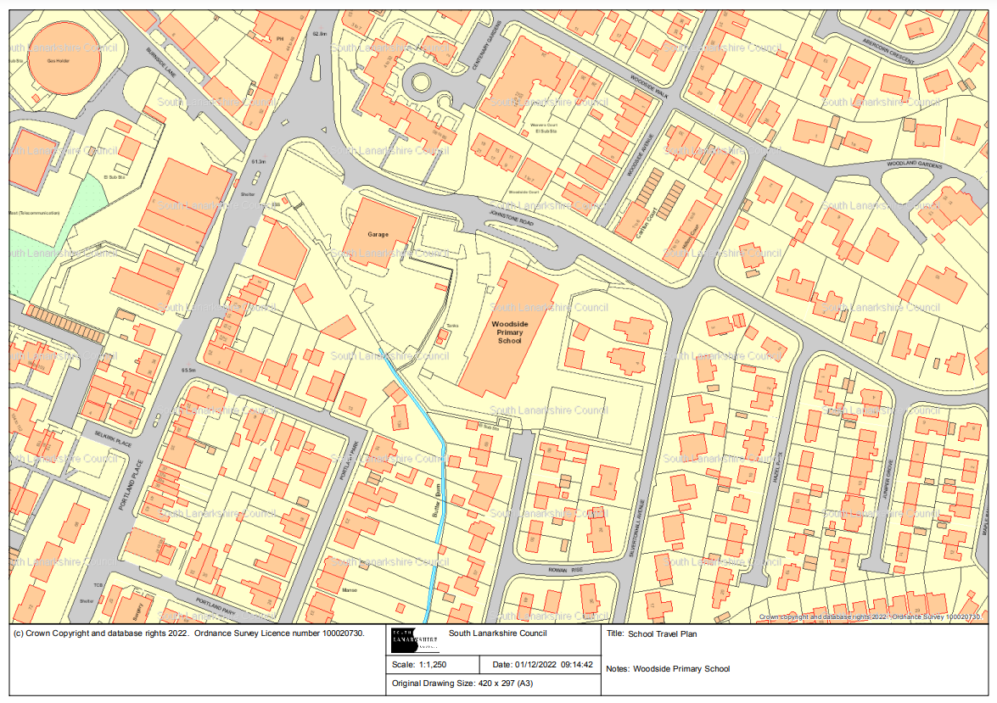
Description of the School

Woodside Primary is a large school close to Hamilton town centre and serves Ferniegair, Barncluith and Eddlewood. Due to our large catchment area, many of our children travel to school by bus. Our current roll is 484 school pupils, aged 4-12 years. We have 17 large classes split over three floors of our building. The new Woodside Primary opened in March 2015.

Our school vision is “Living, Learning and Growing in Woodside,” and our values, Caring, Happy, Confident and Creative are promoted through all our relationships and within our curriculum.

The school is located in the heart of the town. Johnstone Road is a very busy main road, which links to Silvertonhill, Eddlewood and the top end of the town. The road is also a busy local bus route. Next door to the school is a large car garage, that often has large trailer, deliveries at peak times parked outside. Children can also enter the school using Laburnum Lea. This is a quiet narrow residential street where our school gate is situation at the end. Due to our vast catchment, our children travel from various parts of the town to come to school, using a variety of different routes to get there.
Controlled crossings are only available on two of the busier roads.

There is a staff car park on the school grounds and a bus bay the Johnstone Road entrance to the school. Parking for parents bringing / collecting their children to and from school is restricted to the busy main Johnstone Road and nearby narrow residential streets, which can become very congested as children access and egress the school.

Evidence of Consultation

Extensive consultation has been undertaken by the school. South Lanarkshire’s Traffic and Transportation conducted a survey of parents, staff and pupils in October 2022.
From the school roll of 502 pupils, 123 pupils responded in class.

Pupil Questionnaire
Pupils were asked to say how they normally travel to school.
Responses are shown in the following chart:

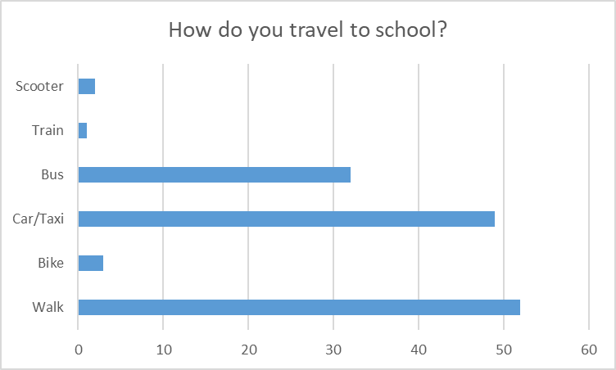

- 52 children usually travel to school on foot (43%)
- 49 children travel to school by car or taxi (40%)
- 32 travel by bus (26%)
- 3 children travel by bike (3%)
- 4 children drive and walk (1%)
- 2 children come on their scooter (2%)

Next, children were asked how they would prefer to travel to and from school. The results showed:

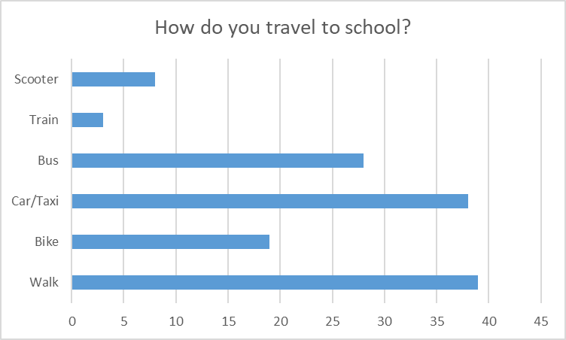

- 39 of children would prefer to walk to school (32%)
- 19 would like to come to school on their bike (16%)
- 38 children would prefer to come to school in a car (31%)
- 8 children would prefer to come to school on their scooter (8%)
- 3 children would prefer to come to school by train (3%)
- 28 children would prefer to come to school by bus (23%)

43% of pupils walking to school is a good number, however 40% coming by car or taxi causes the congestion outside our school. We know that some children come via car or taxi due to the distance they live away from the school.

Parent Questionnaire

287 Parents responded to our Parental Questionnaire.

Parents were first asked how they child/ children normally travelled to school.

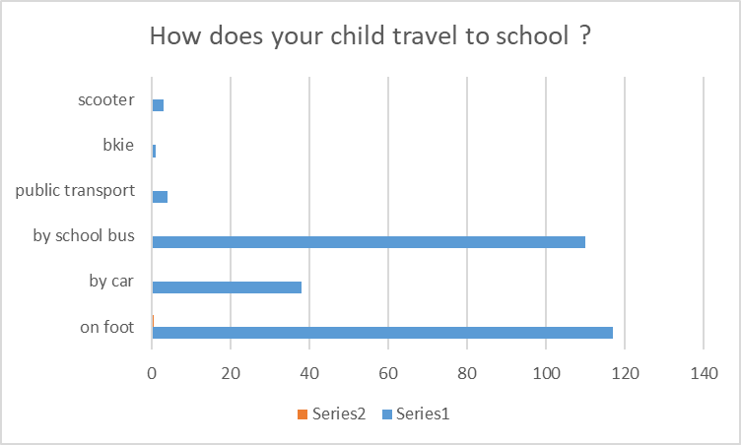

The graph shows that 42% travelled by foot, 38% by car and 39% by school bus.

Due to our vast catchment area, parents were asked how far they have to travel to school.

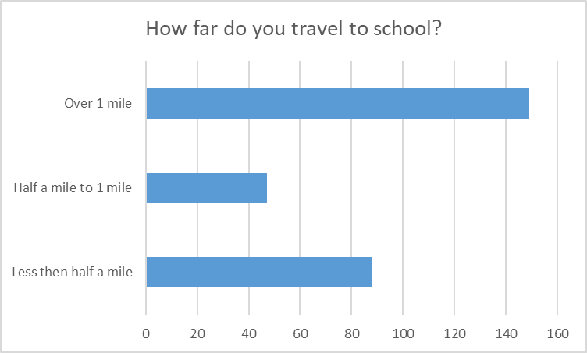

The chart above indicates that more than half (53% of respondents) say their child travels over a mile to reach their school.

Parents were asked if they would consider supporting a 'Park & Stride' initiative - parking further away from the school and walking the remaining short distance. Responses are shown in the following table:

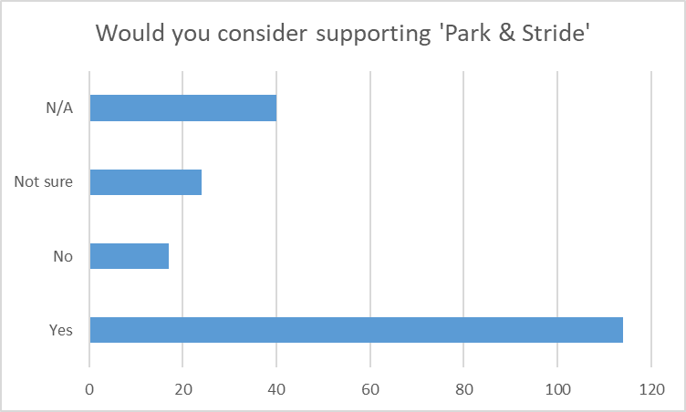

Some reasons for not considering a Park and Stride initiative included:
- Grandparents do drop off / pick up.
- Would depend on distance.
- Not much parking available further away.
- If driving to school it is because are dropping child off on way to elsewhere.
- Time for work is an issue.
- Usually because of time
- My child lives in Blantyre due to personal circumstances.
- On days when I need to be at work there isn't enough time to do this.
- There are no such places other than the front of the school. There are no such places other than the front of the school.
- My child usually travels by bus.
- During summer months when the weather is better. Brighter conditions Yes. In winter / snow / cold / rain No.
- I would agree if there was adequate appropriate parking. I would agree is there was adequate appropriate parking.
- I like to know she get into school safe as gran waits for her at bus stop when walking home.
- It is very difficult to find places to park near and around the school.
- Most parking further away is metered.
- I often have to get home quickly for work.
- When we hit winter and the rain/snow/sleet, it's not practical to not have an easy route to get to a car. Walking 5-10 mins is often enough for the children to be drenched by the time they get to the car.
- I bring the car in the mornings so I can drop my children at different places and get to work on time.
- I don’t have extra time to park and walk.
- Depends how far as time is critical as both parents work and the school day is much shorter than our work days.
- I also have a toddler to take to nursery after school run and who is with me when collecting so weather depending how far away we could park from the school

Respondents were asked if they would be available as a parent volunteer to supervise a small group of children either walking to school. Responses are shown in the following table:

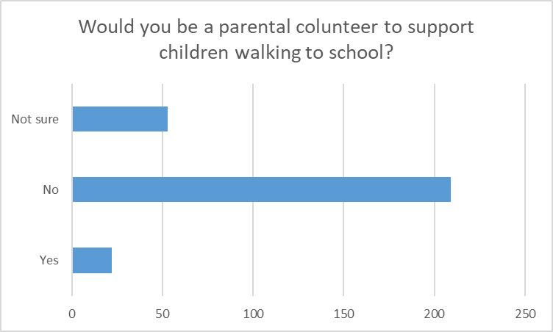

Parents were also asked to say what mode of transport they would prefer their children to use if they were given the choice. The following chart shows the responses given:

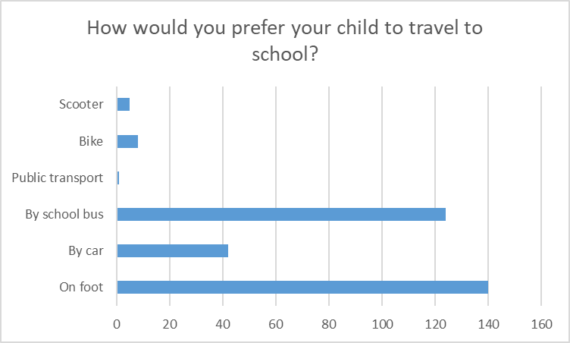

These results show an increase in walking by 5% and a reduction in car use by 23%

Pupils were asked to tick what the barriers are to walking and cycling to school. The results are shown as follows:

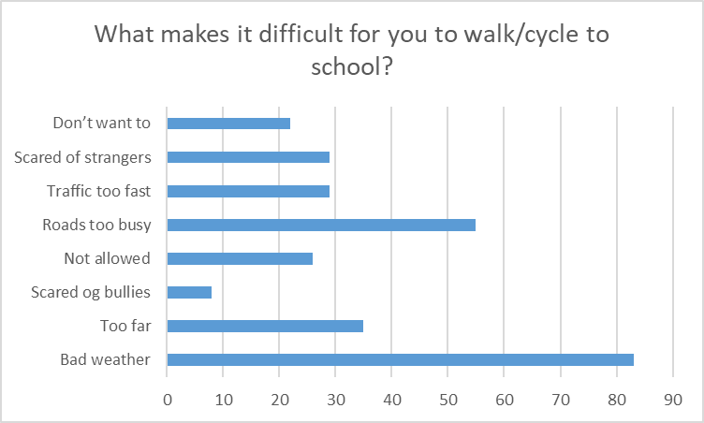

46% of pupils highlighted that the roads were too busy to allow them to walk to school safely.

Pupils Survey Summary

The responses to this survey have indicated that a substantial percentage of pupils walk to school (46%), however a high percentage of the respondents (43%) have stated they are brought to school by car. A total of 79%, of all respondents stated that they would prefer to either walk, scoot or cycle to school.

Parent Survey Summary

The responses to this survey have indicated that a high proportion of the respondents continue to encourage their children to travel to school on foot (42%). A significant percentage of respondents, however, continue to transport their children to school by car and a number of these journeys are carried out with only one child on board (58%).

There was a very poor response from parents who were prepared to volunteer to supervise walking groups (8%) and even less support from parents for initiatives such as cycling groups 1%.

The main points that parents highlighted were:-

169 parents (68%) would like safe places to cross.
117 parents (48%) would like slower traffic speed outside the school

On a positive note, most respondents (71% of respondents) would prefer their children to travel to and from school on foot, but there were still 12% of respondents would prefer their children to travel to and from school by car.

Copies of the full results of our survey are available to view in the school .

Summary of School’s Transport and Road Safety Problems

The location of the school generates many road safety problems. Factors such as:

- Busy main road outside the school
- Extremely limited parking
- Narrow residential streets on one side of the school boundary
- Traffic volume – at peak school times
- Size of school population
- Speed of traffic passing the school
- Pavement areas blocked or restricted for pedestrians due to reckless and illegal parking

There are two school crossing patrol personnel sited at Johnstone Road and the bottom of Low Waters Road however, we believe there is a limited use of this service.

As cited in the Parental Questionnaire, parents view the main road safety problems as:

Cars are now parking on pavement making it difficult for children to walk on especially with prams and cycling would be hard with cars parked up on pavements.

Not so much the journey, but cars driving right up to the gate on Laburnum Lea where there are kids all around, often swinging round and doing big 3-point turns, it's an accident waiting to happen.
- Stop cars driving up to school gates. People running late in morning only care about getting their kids to school and practically running over others.
- Main issue is selfish parents - reduce school catchment so people can walk - Woodside catchment is huge and overcrowded - other schools smaller
- People collecting children by car, not parking on pavements and so close to school. Particularly not reversing their cars down the pavement where children are walking!! Drivers being considerate of other children and local residents.
- There are very limited places to park around Woodside but people continually park over zig zags and also near to the lolly pop man so addressing these people directly
- The problem is cars parking / reversing onto the pavement too close to the school. I have witnessed a number of near misses with drivers not seeing children, in particular smaller children.
- Slower traffic and less double parking

Key Initiatives with Objectives and Targets
Nov 2022

Park Smart

Objective: To encourage safe parking outside the school.

Target: We will liaise with all parents / carers and request they park facing in the same direction on the streets outside the school. We will use campaign such as Park Safe and Kids and Cars Don’t Mix to encourage safe parking practices.

Outcome:

Slow Down

Objective: To reduce the speed of the traffic outside the school and remind drivers the speed limit is 20mph.

Target: We will liaise with parents and display posters to encourage traffic to slow down outside the school. SLC will update speed management system on Johnstone Road
We will organise a mobile Speed sign visit with the Traffic and Transportation Section.
Outcome:

Cross Safely

Objective: All children cross safely on Johnstone Road

Target: We will liaise with our parents and our children to highlight the importance of crossing with the school patroller on Johnstone Road.

Outcome:

General safety and Road Safety within Curriculum for Excellence

Objective: Promotion and awareness of road safety to all age groups covering Road Safety within Curriculum for Excellence

Target: We will encourage walking and cycling promotions, though National Campaigns for example, Walk to School Week in May and International Walk to School Month in October. Bikeability Training will be offered to pupils and we will take part in Junior Road Safety Officer Scheme and Traffic and Transportation’s annual Road Safety Calendar Competition. National and Local Campaigns, received from Traffic and Transportation and Air Quality will be distributed.

Outcome:

Traffic Management Audit / Plan

Objective: Traffic Management Audit was carried out in November 2021.

Target: Observations from the audit included –
- Refresh of yellow zig zags as they are faded
- Pavement parking
- Speed of vehicles
- Engine Idling

A copy of the school’s Traffic Management Plan can be found in the Appendix Section for reference. We will liaise with the Council and partners regarding the above.

Outcome:

Engineering Measures

Objective: Consideration of additional measures to aid the parking/ congestion situation at school peak times as well as reports of inappropriate speed.
- Review of the parking restrictions on Johnstone Road. Previous discussions have included a waiting and loading restriction to the restrictions.
- Further improve drivers’ awareness of the school and the need to drive at an appropriate speed. Consider additional signing / lining to highlight the presence of the school and need to slow down.

Target: Submission of School Travel Plan and progression of above parking restriction changes and additional signing / lining.

Outcome:

Programme for Implementation

We have created a timeline showing our proposed action plan to implement the targets from December 2022.

December 2022
School Travel Plan launched
Poster competition in school
Awareness at school event
Speed awareness

January 2023
Launch of new posters outside
JRSO’s Assembly
Interview the Cross patrol person
Update from Engineering site visit
Park Safe

February 2023
Highlight safe parking in our Newsletter
JRSO ideas
Speed Awareness

April 2023
Bikeability Level offered to P6 Pupils
Speed Awareness

May 2023
National Walk to School Week
JRSO promotion

August 2023
Road Safety Calendar Competition
Safe Start information for New P1 intake
Park Safe Promotion

All targets once started will be ongoing once started and reviewed on a termly basis.
Local and National Campaigns will be repeated on a termly / annual basis.

These initiatives will be actioned as detailed in the Objectives and Targets. The whole school community, including our Junior Road Safety Officer, will be involved in the implementation of the proposals with various groups and individuals taking responsibility for particular aspects.

Monitoring and Review

Progress in meeting the targets within the plan will be monitored and reviewed regularly by Parent Council and staff. Pupils’ views will also be sought through the Junior Road Safety Officers.

The School Travel Plan will be put on the school website and copies will also be available within the school for parents, pupils and local community to view.
The plan will be regarded as an active and ongoing document.

