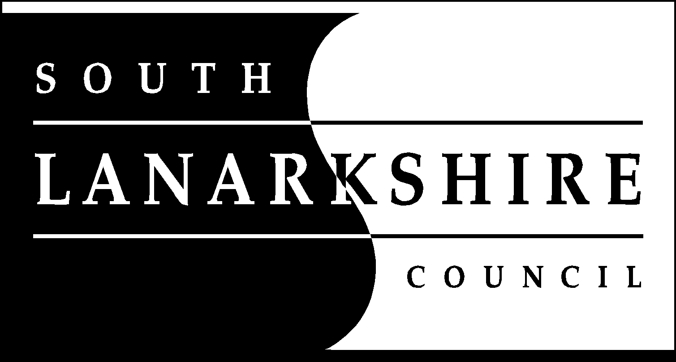
Community & Enterprise resources
Executive Director David Booth
Facilities, Waste & Ground Services

ADAPTED DIET REQUEST FORM
Vegan or Halal

South Lanarkshire Council aims to provide school meals for every pupil. We acknowledge that there are pupils who require adapted diets.
To be able to identify your child, could you please provide a photograph. Please tick the box if you are providing a photo of your child and that you give consent for it to be displayed in the school kitchen with information regarding their dietary requirements and name. Other school staff and contractors may have access to the kitchen. The consent for your child’s photograph can be withdrawn at any time by contacting the Cook in Charge in your child’s school. Please provide the photo to your school kitchen once your child’s special diet is in place. Please tick box to confirm.

School Name: _______________________________________________________

Pupils Name: ____________________________ Date of birth: _______________

Parent/carer details:

Name: ______________________ Relationship: _________________

Address: _____________________________________________________

_____________________________________________________

_____________________________________________________

Telephone No: ___________________

E-mail address: _____________________________________________________

In making this request for an adapted diet, I acknowledge that whilst employees of the council will make every reasonable effort to comply with my child’s dietary requirements, on occasion, this may not be possible due to the manufacturers’ variations to some of their food items.
Please tick which adapted diet you require:
Halal Vegan

Any additional information ______________________________________________

Signature of Parent /Carer: _________________________ Date: ______________

Spreadsheet updated by: _____________________ Date: _______________

Please return completed form for the attention of:
Facility Services Manager, South Lanarkshire Council, Headquarters, Almada Street,
Floor 7, Hamilton, ML3 0AA
You will be contacted to discuss menu options for your child

Privacy Notice – Adapted diet requests (child)
Using Your Personal Information
We will use the information you have given us to in order to meet the child’s special dietary requirement, allergy or intolerance needs.
The adapted menu plans have been approved by parent/carers and passed to the school office, Facilities Officer and Assistant Facilities Officer and catering staff. The school office will be notified if there are any changes/updates regarding the adapted diet procedure.
Facilities services will keep the records relating to the adapted dietary requirements, allergy or intolerance information for as long as the child is at school within South Lanarkshire Council. Thereafter they will be destroyed in line with the Council’s confidential waste policy.
Personal information will only be processed when it is lawful to do so.
Your rights
You have the right to access your personal information as well as the rights of rectification, erasure, restriction and the right to object. For information on these rights and how to exercise them or for information about how we manage your personal information, you can get a copy of our full Privacy Notice from our website www.southlanarkshire.gov.uk by searching ‘general privacy notice’ or alternatively via the link.
https://www.southlanarkshire.gov.uk/info/200176/sharing_information_with_you/1730/general_privacy_notice
Our full privacy notice will also provide information on how to make a complaint or to request a paper copy of the privacy notice from the Data Protection Officer.

