**Woodside Primary School**



**Promoting Positive Behaviour Blueprint**

**January 2024**

**Promoting Positive Relationships Blueprint**

Our Relationship Blueprint is a simple, single sided sheet which is based on a relational approach. It clearly and effectively outlines our school rules, shared routines and a consistent approach and language used by all staff across the school. This has been formed in consultation with all our children, staff, and parents.

Our children are full of enthusiasm! They are also interested, caring, respectful and proud of their school. After consultation with our whole school community on our values and expectations of how we think a good school should be, together we came up with **HAPPY, CARING, CONFIDENT** and **CREATIVE**. Our children and staff within school talk frequently about these values and attempt to always model them.

In Woodside, we work hard to create and maintain a very positive, friendly, vibrant school ethos. Although a large school, we are a family. Everyone has a part to play in this – Head Teacher and Deputes, Principal Teacher, the Staff and Support Staff Team, Janitor, Dining and Cleaning Staff, Pupils, Parents, Partners, Volunteers and Friends.

*“Relationships matter; the currency for systematic change is trust, and trust comes through healthy, working relationships. People not programs, change people” Perry & Szlavitz2017,p85*

**Why are relationships important?**

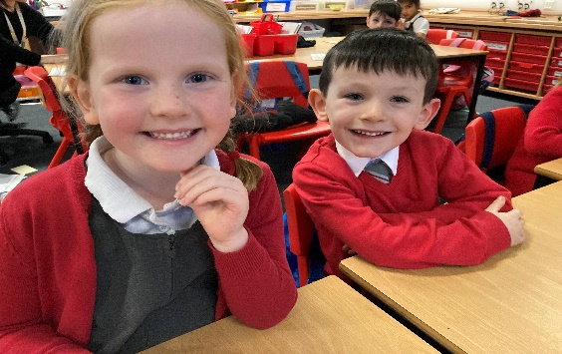

• Imperative to effective teaching and learning

• Enhances motivation and engagement

• Creates a positive learning environment

• Improves classroom management

• Enhances and promotes positive school ethos

• Enables learners to feel safe and secure

• Creates a nurturing environment

Our practice is underpinned by the idea that all behaviour is communication. This allows for a child-centred approach leading to positive solutions to support children if they demonstrate distressed behaviour. It has been created in consultation of all our pupils, parents and staff and takes account of guidance from the following: -

* SLC Promoting Positive Relationships and Understanding Distressed Behaviour
* SLC Attachment informed practice
* When the Adults change everything changes by Paul Dix
* Know me to Teach Me by Louise Bomber
* GIRFEC

We recognise that our relationship Blueprint is not a ‘one size fits all’ and at times we need to differentiate our approach in order to meet some pupils needs.

**Anti Bullying Behaviour**

South Lanarkshire Council is committed to providing a safe, supportive environment for all people in its educational establishments. The Council’s Policy ‘Treat Me Well’ can be found on the South Lanarkshire Council website.

Bullying is a breach of the UN Convention on the Rights of the Child. In Scotland, bullying is defined thus:

‘**Bullying is both behaviour and impact; the impact is on a person’s capacity to feel in control of themselves. This is what we term as their sense of ‘agency’. Bullying takes place in the context of relationships; it is behaviour that can make people feel hurt, threatened, frightened, and left out. This behaviour happens face to face and online**.’ (respectme 2015)

Bullying behaviour happens face to face and online and can include:

* Being called names, being teased or made fun of
* Being hit, pushed or kicked
* Having your belongings taken or damaged
* Being ignored, left out, or having rumours spread about you
* Being humiliated
* Receiving abusive messages or having nasty comments made about you online
* Being targeted because of who you are or how people see you

This can hurt you physically or emotionally and, although the behaviour might not be repeated, the threat or worry that it will happen again can be very real.

At Woodside Primary we share the Scottish Government and South Lanarkshire Council vision that bullying is never acceptable, and that children and young people have the right to learn in a safe, secure environment. We are committed to challenging all types of prejudiced-based bullying and language, including in relation to the nine protected characteristics detailed within the Equality Act (2010):

• Age

• Disability

• Gender reassignment

• Marriage and civil partnership

• Race

• Religion or belief

• Sex

• Sexual orientation

**Children’s Rights**

It’s every child’s right not to be bullied. Children’s rights are unique in that many of them, although designed for the safety and protection of children, have to be provided for by adults and the government It’s every child’s right not to be bullied.

Although children and young people are covered under the Human Rights Act 1998, their rights are more clearly specified under the UN Convention on the Rights of the Child (UNCRC).

Although neither specifically mentions bullying, bullying behaviour does breach a number of the articles in both. Alongside this, both outline the responsibilities of adults to protect and safeguard children and young people from bullying behaviour.

**Is intent required?**

Every bullying incident should be looked at individually. In some cases, children or young people may not be aware that their behaviour is actually bullying. They are perhaps modelling the behaviour of adults or other children and young people, not understanding that it is wrong because they have never been taught otherwise. In these circumstances, the intent to bully may not be present, but the impact and effect on the person being bullied will be no less severe because of this. It must be explained to the person bullying that their behaviour is unacceptable and why. Intent is difficult to prove, and young people can often reframe their behaviour when challenged. It’s more important to focus on the behaviour and the impact it had, rather than trying to establish whether someone acted deliberately or not.

**What about impact?**

Bullying can affect people in different ways, and this should be taken into consideration. If anyone is unsure if behaviour is bullying, look at the effect it is having on the child or young person. Keeping the focus on impact reduces the emphasis on issues of persistence and intent. ***What we do about bullying is more important than how we define it.***

**What about conflict?**

We should always remember that children will tease each other, fall in and out with each other, have arguments, stop talking to each other and disagree about what they like and don’t like. ***This is a normal part of growing up and should be distinguished from bullying.*** However, in an environment where this behaviour is left unchecked, it can lead to bullying, making those being bullied feel afraid, uncomfortable and unsafe. All behaviour communicates feelings. Our response should focus on identifying how someone feels and help them to cope with and respond to those feelings.

**What about online bullying?**

For children online platforms are social spaces where they can hang out and meet friends. Like any other place they visit, there are benefits and risks. Adults need to be engaged with children about what they are accessing and who they are chatting to. We will not treat online bullying, or ‘cyberbullying’ any differently; it’s still about behaviour and impact.

**Handling Bullying Incidents**

We recognise that despite our best efforts to promote positive behaviour incidents of bullying can still occur. Fundamental to our policy on bullying are the following principles:

* All bullying is unacceptable, regardless of any excuses that are given to justify it.
* Every incident of reported bullying will be investigated fully.

**School Staff will:**

* Demonstrate positive relationship behaviours through their interactions with the children and each other.
* Introduce early intention supportive strategies when they observe changes in individual pupils’ relationships or class dynamics.
* Talk about and distinguish the differences between what is bullying and what is conflict at Assemblies and in class.
* Listen to the children and establish the facts of a reported incident –is it bullying?
* Report all incidents of bullying or suspected bullying to the management team.
* Ensure pupils do not use their mobile phones or smart watch whilst in school.

**The Management Team will:**

* Fully investigate and speak to all concerned.
* Maintain appropriate records using an agreed school proforma. (See Appendix 1)
* Involve parents at an early stage.
* Possibly working with parents through behaviour charts etc.
* Be sensitive to the feelings and fears of all children involved.
* Record incidents using school paperwork and the SLC SEEMIS format.
* Work with all concerned to find solutions, restore self-esteem, and prevent further incidents.
* Spend time with child at the ‘Solution Stop’ at either breaktime or lunchtime.
* Undertaking class work with DHT/HT.
* All supports/interventions will be differentiated to meet the needs of the child/children involved.
* Enlist the help of specialist staff where necessary. eg, Place2Be, Educational Psychologist, Youth, Family and Community Learning Officer
* Monitor pupils involved to ensure that the situation is resolved.
* After 2 weeks meet with all pupils again to see if the situation has been resolved.
* Take appropriate action in all cases of racial, disability or gender harassment in line with SLC procedures.

**We would like parents to:**

* Ask the school for any supports if needed. (Phone Mrs McKellar for Primary1-3 pastoral supports and Miss Officer for Primary 4-7. Mrs Renwick for whole school supports.)
* Actively support our Anti-bullying policy and our Relationships Blueprint by discussing this with your children.
* Be open- minded and establish the facts of an incident. Is it bullying or ‘conflict’? Are there two sides to the story?
* Notify the school as soon as possible about bullying incidents. Don’t wait for things to resolve themselves. We are here to help! Encourage your child to tell someone about bullying incidents. The sooner we know about a problem, the sooner we can sort it out
* Work in partnership with us to resolve the situation. We want every child at Woodside Primary School to feel safe and cared for.
* Ensure your child has their mobile in their school bag and it is switched off as soon as they enter and leave the school gates.
* Monitor your child’s use of social networking sites, gaming platforms and messaging services and use of their mobile phone/ smart watch whilst outside of school. Take appropriate action such as removing your child from games, chats etc.
* If your child travels on the school bus, ensure you follow the School Transport agreement.
* Read the parental guidance outlined on the ‘respectme’ website and online guidance from ‘thinkyouknow’ website.
* Access parental workshops when offered.

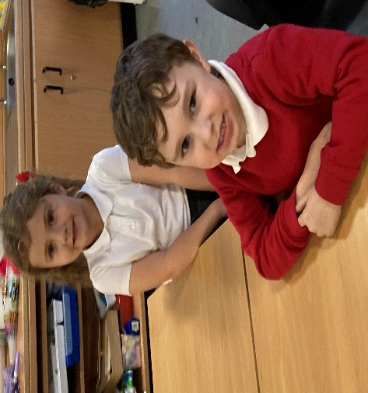**We would like children to:**

* Tell a teacher, parent/carer, or friend if you are being bullied.
* If you see someone being bullied, tell an adult as soon as you can.
* You can use the ‘Solution Stop’ to discuss any conflicts or worries every playtime and lunchtime.
* If you feel like you cannot tell someone, note your worries about bullying in our school ‘Bullying Box’.
* Remember that bullying can be fixed if everyone works together.
* If you bring your mobile phone or smart watch to school, please switch it off and keep it in your school bag all day.
* Be safe, be caring and be responsible when playing games online or using your mobile phone.
* Be safe, be caring and be responsible when travelling on the school bus.

**We all work together to create learning environment that is built upon positive and nurturing relationships to ensure all children feel safe, happy and cared for in Woodside.**

**Appendix 1**

**Relationships Monitoring Form Bullying Conflict**

**Date Time Location**

**Persons involved:-**

**Reported by:-**

**Alleged Incident**

**Physical Verbal Other**

**Details**

**Action Taken**

**Solution stop time Phone call home Time with SLT**

**Further incidents**

**Two week monitoring review date :-**

**Situation resolved Situation not resolved and recorded on**

**SEEMIS**